**Data Exploration**

1. Choose the data set assigned to you.
2. Load the data into a data frame, no data loss is allowed because of conversion.
3. Remove the ID column and load the data into another data frame
4. Delete the original Data Frame
5. Remove the Rows with invalid values
6. Factor the data High, Medium, Low as 1, 2, 3
7. Remove any unwanted symbols, data without data loss
8. Convert the Value Data to number. No NAs should be introduced
9. Convert Date to valid Date format. No NAs should be introduced
10. Convert Attribute to Character
11. Calculate the hourly Average of all the all the attributes
12. Which hour has the maximum number of observations in the day
13. Which hour has the maximum “High” No2 in the data
14. Plot a bar graph showing the hourly count for each hour also show the distribution among the attributes for each hour. Op should look something like this

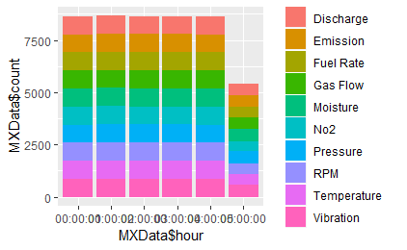

1. Combine Hour and Day Together to a single column
2. Transpose the table in such a way each of the attribute becomes a column name and the rows contain the hourly average for each hour. Output should looks something like this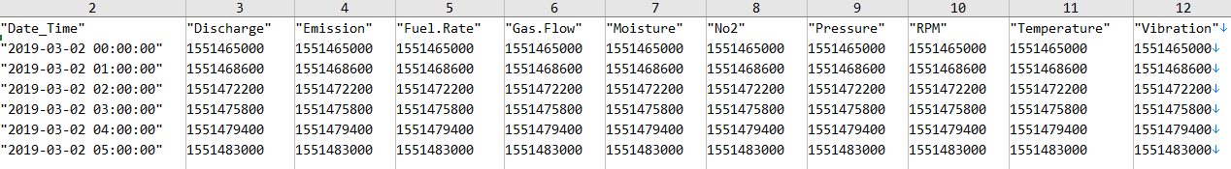
3. Find the highly correlated attribute pair and visually represent it.